**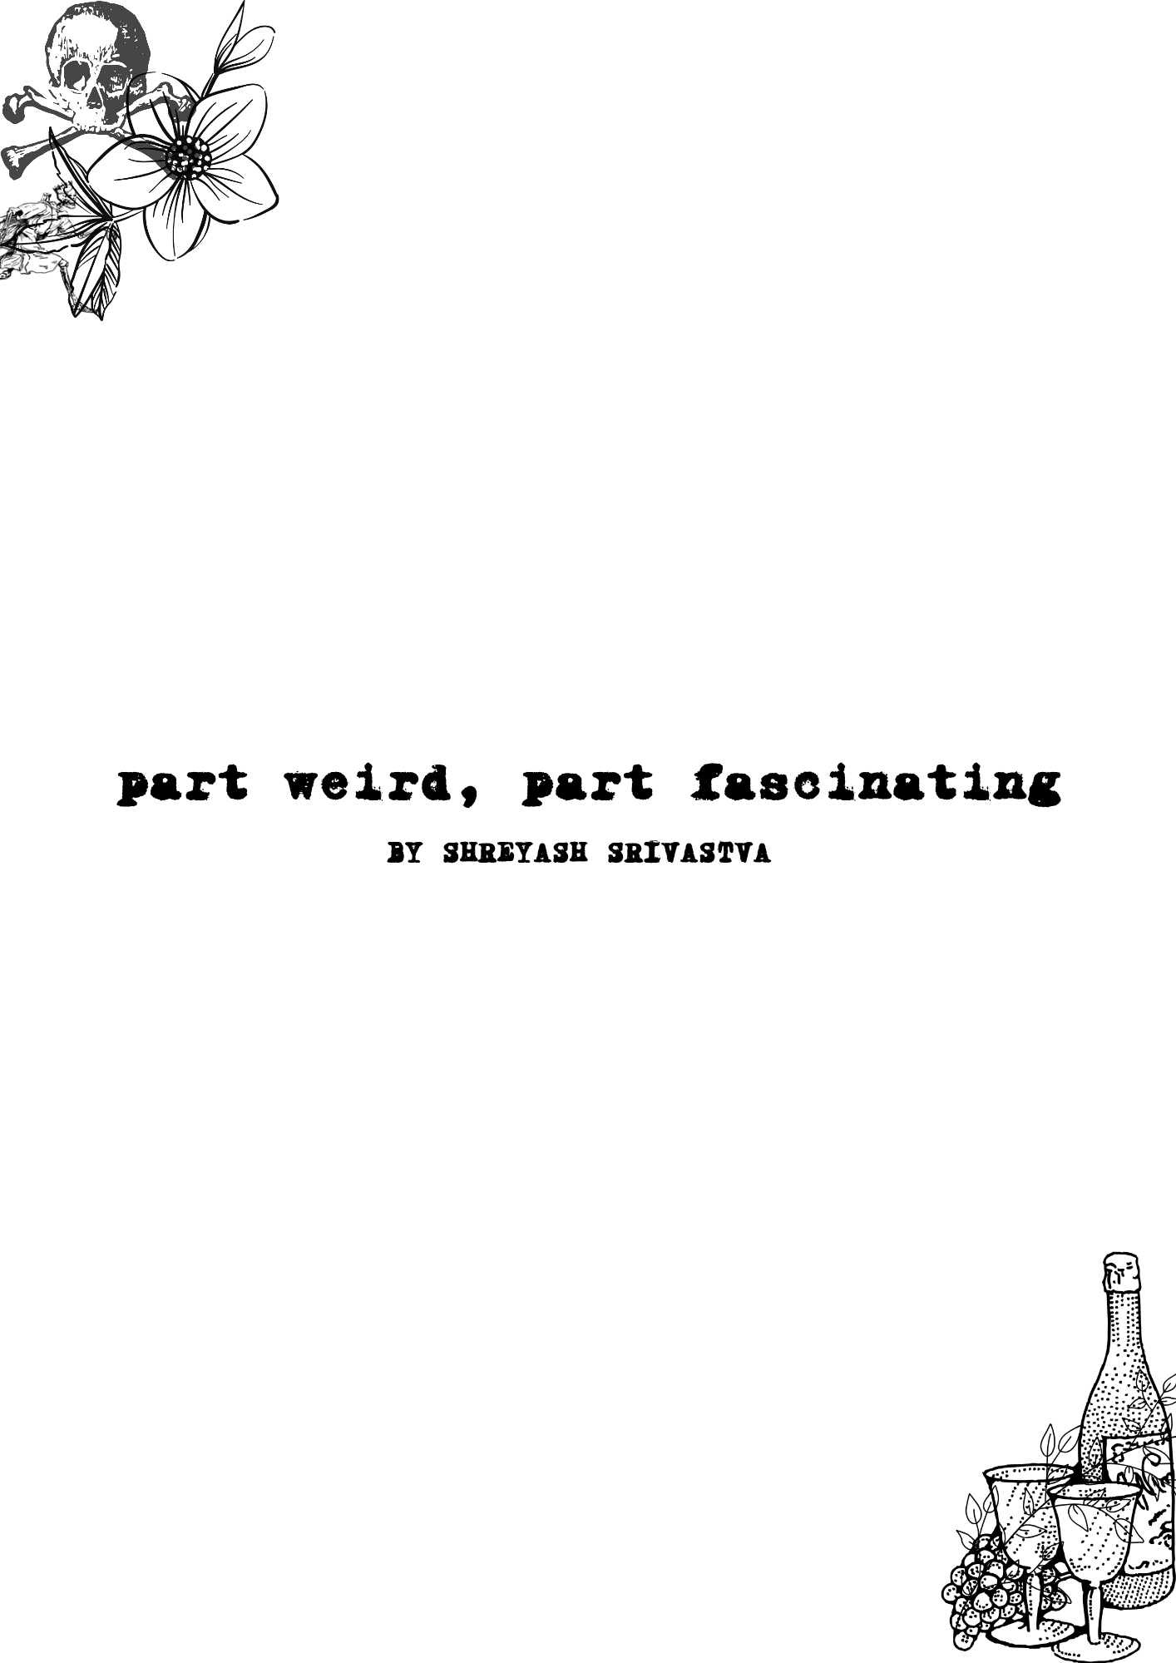**

**part weird, part fascinating**

**BY SHREYASH SRIVASTVA**

### ****Foreword****

part weird, part fascinating

This is not a collection.  
It’s a confession.

These are the words that happened between heartbreaks and hopes, a few about me and a few about others who couldn’t scream loud enough, so I decided to just write instead. Some of these poems are ugly. Some are absurd. Some are bare, stripped of everything but feeling. All of them are mine—and maybe a little bit yours too.

This book wasn’t planned and a big portion of it was written in just one sitting. It just… created itself into existence. Every line came from something I felt too deeply, saw too clearly, or tried too hard to forget. I don’t write poetry to sound wise or lyrical. I write because it’s the only way I know to survive a moment without explaining it.

So if you find yourself somewhere in these pages—loved, heartbroken, healing, cynical, enchanted, or lost—just know that you’re not alone. Maybe we’re all a bit weird. And maybe that’s what makes us fascinating.

Here’s to what we’ve lost.  
The person we became.  
And the strange beauty of being human.

**Copyright © 2025 Shreyash Srivastva**  
All rights reserved.

No part of this book may be reproduced, stored in a retrieval system, or transmitted in any form or by any means—electronic, mechanical, photocopying, recording, or otherwise—without the prior written permission of the author.

This is a work of poetry. All characters, references, or situations are either fictional, symbolic, or used in an artistic context. Any resemblance to actual persons, living or dead, is purely coincidental.

Cover and interior design by Shreyash Srivastva  
First Edition

For permissions, collaborations, or inquiries:  
*[shreyash5183@gmail.com](mailto:shreyash5183@gmail.com)*  
[www.linkedin.com/in/shreyashsrivastva](http://www.linkedin.com/in/shreyashsrivastva" \t "_new)

**for the ones who inspired this work and the ones who are**

**weird and fascinating in their own ways.**

**flawed, cool and amazing.**

****contents****

i need to save myself  
insect  
my ego  
wait  
but i still…  
he used to  
my lovely dear  
helium  
playground  
redpill tutor chad  
to motivate  
100 years  
highway not traveled  
a charming boy  
if i die today  
he's gone  
honey i like you so much  
parcels: the band  
my fairy  
to myself  
i wonder  
replaced by new  
lost!  
in melancholy, part 1  
in melancholy, part 2  
i  
studio ghibli  
wiser  
deHeartes  
be  
they taught us shit  
endless love he has for her  
plastic love  
thieves of hearts  
clouds  
gutter of love  
bullshit levels of toxins  
mumma shark  
tavernlove  
carpet  
eww  
showcase of broken hearts  
tears no more

**i need to save myself**

i need to save my smell

to take in your body aroma

and nothing putrid otherwise

i need to save my audition

i want to listen your melody

not the background noises

i need to save my vision

just so to look at you

neglecting all they say beauty

i need to save my bones

so i don't turn some octopus

spreading on you like mayo

i need to save my tongue

to taste the food you are

switching to you for glucose

i need to save my skin

so to wrap around yours

and not my bloody flesh

i need not to save those

they call heart and brain

cause I'm losing 'em for sure

**insect**

i'll be an insect,

a mosquito.

that sucks your blood

even a drop of it can

suffice my weel

if i can't be a vamp

**my ego**

you killed that like an ant

which once was an elephant

**wait**

To Patience,

Fuck You.

Regards.

**but i still…**

i long for you

even when you’re long gone.

like a pig

i roll in mud

with the muck that i made

out of my love for you

and the shit equivalent importance

you have for me.

in your love

i've become filthy.

**he used to**

he used to beat his wife

so god took his left eye

now he does domestic violence right

then one day his wife called cops

so he did beat her harder

but police made quick response

and found him red handed

but the only problem was

collecting the pieces of her skull

**my lovely dear**

my lovely dear

you are like some cartoon

but i still love you

**helium**

you fill me up like helium

and launch me to the skies

**playground**

i hate i never had good playground life

never too far from ground

never too close to it

maybe i should have been sociable

i am trying.

**redpill tutor chad**

i have seen you getting blind for her

and now you teach me redpill

**to motivate**

if you won't get up today

life will shit on you

and when life shits

it really hits

but after some time

you'll get used to crap

you'd say that's ok

and make yourself wrap

and until you'll realise it

you're deep in that trap

and stuck all inside

that everest load of crap

and as you compile

that mount load of shit

which you can't clean

where you stand still

in your numbness

you human equivalent of shitness

with due respect

in your fucking dumbness

get up and go

and clean some

and rest will go

**100 years**

100 years, give me today

and that still is going to be short

for me to simp over you

**highway not traveled**

two roads diverged in a wood,

and boy I took the highway,

and that has made all the difference.

**a charming boy**

he was a charming boy

of his famous town.

he was so different that

he played girls to impress the guitar.

**deHeartes**

i simp, therefore i am.

**he's gone**

he went to some college

made friends

they made some friends

his friends have friends

he's left alone

he's seen walkin’ with earphones

talking to himself

lonely but looks fine

i asked him, he said the same

he looks not although,

i saw in his eyes.

but he grabbed his dew

and said a warm goodbye

i wish he had friends

no i should be his friend

where is he

hello! sir, have you seen him?

pardon! ma'am have you seen a guy,

umm.. he had a grey bag black earphones

guess i'm late

guess he's gone

but one thing i still remember,

we were talking about how he's alright

and why there's no friend with him.

he told me with all his excitement

and a strange but subtle smile

"i keep my friends close

and enemies in closet

**honey i like you so much**

honey i like you so much

but you're an optional subject

and i have many backlogs already

so I'll kiss you a goodbye.

**parcels: the band**

calmanddramatic

bittersweetmelodic

amazinglycomposed

thatilovesomuch

andwhatelsetosay

ireallythinkthat

andihavesaidenough

**my fairy**

you call it madness,

i call it love.

if i'm obsessed,

why shall i not.

**to myself**

to myself,

yes me, to myself.

i see those days,

those good old days.

i remember those

eyes open, eyes close.

i wish to go back

sometimes i pass those track.

walk a mile there

being awake, being aware

but now i won't go there

i don't love that snow.

my streets are new

i want snow that's new

i will live in awe and wow

i will live in here and now

irrationally yours

**i wonder**

i wonder

i ponder

yet i find no meaning

let’s be absurd anyway

**replaced by new**

i deduce

you're of no use

to me

move,

i don't know thee

discarded are ye

for change, to renew

i'm going without you

discarded are you

replaced by new

**lost!**

he for once

was very close to that,

very close to the shore he was.

about the time he was to touch the shore

a wave, a huge heart breaker came,

it took him with it far, far away from there

distance between him and the shore

grew more and more from everywhere

thence was he lost

lost was he thence in immense waters

never to come out

never to reach his destination again

longed thence he nothing more

but one thing, his desired shore.

**in melancholy, part 1**

i, in melancholy

scream’d your name

desired your presence

scream'd nothing but your name

want your presence

still you i hate

i don't know why

desired you for being my mate

melancholy is reason for why

**in melancholy, part 2**

i, in melancholy, stayed not long.

devised a plan to come out young

as a new self still the old soul

i engaged to my mind

married to my soul

they aren't different, but one alone

i am desire, the passion personified

use me as an allegory

for i win worlds,

of here,

and those present everywhere.

**i**

i, walking down the street

looked for humans,

the very human traces

i found none

just different faces.

all somehow confused

in misery, fully fatigue fused

so i stole my eyes away

and looked all above

very high

right to the night sky

and what i saw, was hope in my case

your face

the very human trace.

the antidote to loneliness

and a real source of true love.

**studio ghibli**

admiration i have for them is endless

these movies have something strange in them

they are awkwardly sweet

sometimes shy, sometimes sad

all in all, a slice of life.

a life in a slice.

and of course endless beauty.

**gutter of love**

i'm a pig

rolling in your gutter of love

**wiser**

integrated in my machine

is the element to be keen

of curious things

of talking beings

yes of walking monkeys

those talking monkeys

too

shoo

i don't know if it's for you

but it's entirely new.

firstly, one thing you must redeem

the power source of meaning

your very self esteem

two you should learn to say no

be it diplomatic or direct

say, if you want and then go

third is the element called focus

attentive mind on the locus

and sliding away all that is bogus

i don't want to be more nicer

but three times wiser

**be**

we all have this one fucking life

why waste it pretending

and saying we could have been

why try

why shy

rather then doing what ought to be

**they taught us shit**

they taught us rules

taught us how to spell jewels

then told some different joules, and

we were just sitting on our stools

in unison shaking heads like fools

**if i die today**

if i die today

and if you don’t have

my parents’ number

you won't ever know

phones don’t notify on DND

**endless love he has for her**

i put the world on fire

to have some light

for i am here writing poems for my love

**plastic love**

it's plastic love. hard to degrade.

**clouds**

oh clouds that wander

in the endless skies

a mere glance on them

for us will suffice

where below them are all

where grasses are green

peaks high, streams are lean

all to fulfill the tranquil sense

of a supernatural dance

and here we all are a part of it

**bullshit levels of toxins**

ye nature,

that hath crafted me,

how troubled my soul

hath grown this day.

for i canst hear she quoth,

thine enchanting voice today!

ohh! i grow frightened,

shalt i part the very planet i tread

to the stellar night coloured ether voids,

oh! to the heavens

to the infinite hour long of somberness.

with all my might and potent

longs my soul for thy melody of speech.

**thieves of hearts**

save someone, now you own that person.

how strange that is!

**mumma shark**

bite me like a shark and chew me

still you can't engulf,

out of indigestion

all the

never decomposing parts of me

made out of my love for you.

**tavernlove**

you are one hell of a bottle opener,

and as you open my cork off,

and let my sorrows out,

flow out in fizz.

**carpet**

perchance you stepped your foot,

on my chest milady.

but wait! don't lift it up,

please consider this as your new carpet

from now on.

**eww**

about you,

even a poor thought, kills my soul dear

to the lengths you can't imagine,

out of your bag of filth you call mind.

i swear to god of every religion,

taking my life comes as a better option.

but wait that will be a shame, an insult,

a disgrace even when i think,

taking life for a substance that already rots,

you must choke in silence,

until your mind vomits at the brink.

**showcase of broken hearts**

i'll fit you in a bottle

and steal you away from the world

with a promise of true love.

and take you to my very place,

where i showcase all those hearts,

that thought i have one.

**tears no more**

don't hold those tears dear,

let them flow babygirl.

off your pacific eyes,

rolling down those tender ones,

those mild nature's creations.

those cheeks,

flowing over them,

those saline elixirs,

and for them

i'm there like a baby for milk,

with my mouth open, tongue out.

Engulfing, vaporizing every single drop,

i'm a sandy desert now!

**About the Author**

**Shreyash Srivastva** is a poet, technologist, and creator of contradictions—part scientist, part dreamer. He lives where logic meets feeling. When he's not building AI systems or writing research papers, he bleeds into poetry—raw, real, and rarely restrained.  
This is his first poetry book. But not the first time he’s turned thoughts into something poetic.

You can find more about him and reach out at:  
instagram: <https://www.instagram.com/shreyazh>

twitter: <https://www.x.com/iamsrivastva>

linkedin: <https://www.linkedin.com/in/shreyashsrivastva>

thank you

to everyone  
who ever hurt me  
or healed me.

you gave me words.

to those who stayed,  
and especially to those who left,  
you gave me stories.

to the unknown readers,  
thank you for opening these pages  
and meeting me where I’m most honest.

to poetry,  
thank you for letting me bleed without stains.

rationally yours,  
shreyash srivastva